**Title**: Replicating “Interpreting Culturally Rich Realities: Research Implications for Successful Interpretation”

**Authors**: Brittany Patten and Jacqueline Fernaays

**IEP Program**: Northeastern University

**Mailing Address**: 21 DeSoto Ave, Framingham, MA 01702

**Telephone Number**: 617-955-6234

**E-mail address**: [brittany@aslgirls.org](mailto:brittany@aslgirls.org)

**Word Count**: 5,089 (24 pages)

**Biographical Sketch**: Brittany Patten grew up with a younger sister who is deaf. Inspired by her sister, she decided to pursue an interpreting career and enrolled at Northeastern University in 2011. Brittany graduated summa cum laude in 2014 with a Bachelor of Science in American Sign Language/English Interpreting and Linguistics; she has continued on, getting her Master of Education in Language and Literacy from Harvard University. She would like to thank all of her teachers and fellow classmates at Northeastern for their support and guidance on her journey to become an interpreter, and she hopes this research will inspire interpreters to continuously work on and improve their skills.

Replicating “Interpreting Culturally Rich Realities: Research Implications for Successful Interpretation”

Brittany Patten and Jackie Fernaays

Northeastern University

Abstract

In 2001, Dennis Cokely, PhD, CSC, published an article focusing on English words that have taken on “Deaf-centered” meanings for interpreters. The results from the study showed that although interpreters have acquired the frames necessary to comprehend culturally rich realities, those for whom the interpretation is intended, more than likely, have not acquired those same frames. Almost thirteen years later, the main purpose and aim for replicating the original study was to see if and how the general population’s perception of American Sign Language (ASL) has changed.

*Keywords*: interpreting, American Sign Language, ASL, culturally rich realities, deaf-centered

Replicating “Interpreting Culturally Rich Realities: Research Implications for Successful Interpretation”

**Culturally Neutral and Culturally Rich Realities**

Culturally neutral and culturally rich realities exist within linguistic communities; inside these linguistic communities, members have shared world-views and shared social experiences (Hymes, 1964). However, a linguistic community is rarely isolated from other linguistic communities, meaning members of the overlapping communities are likely to have certain shared experiences and shared values.

The realities (i.e., values, beliefs, etc.) that are similar for the communities in contact with each other are known as culturally neutral realities, while the realities that are unique to each community are known as culturally rich realities. As Cokely (2001) states, “culturally neutral realities are shared; culturally rich realities are not”.  Examples of culturally rich realities can be community specific, confined norms, specific values, and unique world-views (Cokely, 2001).

Based on the degree of proximity, some communities-in-contact with one another can experience more culturally shared, or neutral, realities, whereas other communities-in-contact that do not share the same world-views can have unique and culturally rich realities (Gumperz, 1964). Communities-in-contact with one another that experience more culturally shared or neutral realities means that their world-view is more similar to one another. However, all of the views are not all similar, leading to multiple culturally rich realities.  When interpreting, interpreters are not only representing meaning in another language, but they are also responsible for cultural mediation between two persons or groups from different communities (Katan, 1999).

**Semantics**

The responsibility of interpreters to convey meaning and mediate culture falls into the category of semantics, which is generally defined as the study of meaning. As identified by semanticist John Lyons (1971), language aids communication. In other words, sense can be thought of as the content of a message; the lexical meaning, on the other hand, is the meaning of individual words (Kearns, 2011). According to Cokely (2001), “the semantic sense of a lexical item is that reality or idea that a community of users generally associate with or wish to refer to when they use that lexical item”.  Therefore, the semantic sense of lexical items is closely related to culturally rich and culturally neutral realities.

Lyons (YEAR) states, “there can be no doubt that these different senses of the world […] are interconnected; and various definitions have been proposed that have sought to bring them under some very general, but theoretical, concept defined in terms of social interaction” (p. 32). While there are lexical items that contain one semantic sense, most languages contain lexical items that have more than a single semantic sense (Cokely, 2001).

The same is true in American Sign Language (ASL). When interpreters see a sign that has multiple semantic senses, he/she must decide what that sign means in terms of the basis of context and goals that match the semantic sense of the sign that is intended. Hoffmeister (1994) proposes that three vocabulary skill levels exist: knowing a definition, knowing how a sign is used in context, and knowing similarities and differences among the meanings of signs. Once the semantic sense of the source language is matched with that of the target language, the interpreter must then choose an English lexical item that matches and conveys the same point as it does in ASL.

In addition to vocabulary skills, when people speak, oftentimes they mean more than they say, therefore leading to presumptive meanings that interpreters are left to decipher (Levinson, 2000). A concept expressed in ASL often cannot be conveyed by a single all-purpose English word. Likewise, English words and phrases may have variations in meaning. Due to this, interpreters must focus on the overall message of what is being spoken or signed instead of focusing on the lexical level.

**The Interpretation of Meaning**

In 1980, a distinction between interpreting and transliterating was made at the RID Convention; it was made clear that it is an interpreter’s duty to render the *meaning* of the message in an interpretation rather than simply replace items at a lexical level (Quigley and Youngs, 1965).  This further emphasizes that a lexical item that is used in the English-speaking community does not always have one sign that represents that item in ASL.  The following example portrays different semantic senses, while keeping the same lexical item:

            1. ‘run’

1. John will run the meeting this afternoon.
2. John will run in the race next month.

The interpreter would render the target English lexical item in the first sentence of the example (1a) very differently than he/she would render the target English lexical item in example (1b). If the interpreters tried to use the same signs in each sentence, the appropriate meaning would not be expressed in ASL.

Many interpreters formulate their interpretations based on an “Equivalence of Meaning Test” (EMT), a cognitive process that requires the interpreter to first understand the meaning of the source language and use their judgment to convey an equivalent message into the target language, all while taking into account the different cultures involved (Cokely, 2001). Yet, this does not always guarantee a successful interpretation.

Danica Seleskovitch, a French conference interpreter, proposed that successful interpreting is based on an understanding of the message in the source language. Moreover, the translation of the original message into the target language does not simply rely on the words of the original message, but focuses on the overall sense (Seleskovitch, 1975). While undergoing this cognitive process, the interpreter must also take into account the register and style of the speaker. The remainder of this article will address the question of what semantic senses interpreters convey by rendering interpretations of culturally rich ASL realities.

**Survey**

In Cokely’s (YEAR) original study, a survey was created consisting of eight English words. These eight words were selected from a list of approximately fifty lexical items and were chosen based on their frequency of use within interpretations. For the current study, the original eight words remained in the survey to see how the results would differ almost thirteen years later.

In addition to the list of original eight terms, a ninth term was added along with three open-ended questions. The open-ended questions were based on recent events that have brought ASL interpreters into the national and global spotlight.

**Foundation of the Open-Ended Questions**

In the wake of Nelson Mandela’s death, one man made national headlines for his interpreting performance at Mandela’s wake. He stood onstage gesticulating gibberish in front of a global audience, outraging deaf people and providing a negative example of interpreters and their roles. In the weeks following the event, interpreters were harassed and jokingly asked whether they can actually sign. The occurrence was a disgrace for members of Deaf communities trying to view the ceremony - they were denied access to the memorial due to the choices of this one interpreter, wno made a mockery of sign language and portrayed interpreters in a negative light.

Prior to Mandela’s memorial service, Mayor Bloomberg’s addresses to the state of New York during Hurricane Sandy also drew attention to his ASL interpreter, Lydia Callis. Callis quickly made headlines in news reports across the nation. Articles entitled, “Lydia Callis, Bloomberg Interpreter, Warms Hearts as Sandy Sweeps through New York” (The Huffington Post) and “Lydia Callis and the Biggest Industry You’ve Never Heard Of” (Forbes Magazine) were published nationwide. The famous late-night television show, *Saturday Night Live* even did a skit portraying Callis and her interpreting job.

In more recent news, Jimmy Kimmel’s late-night show hosted an ASL “rap battle” with rapper Wiz Khalifa, a deaf woman, and two ASL interpreters. The two interpreters and Deaf woman took turns signing Khalifa’s rap in ASL. To most, the rap battle was the most amazing thing they have ever witnessed relating to sign language. To those within the Deaf community, however, the rap battle took on a different emotion. This event did not occur until after the current survey was completed, however, it is important to note that there is an increasing amount of media coverage focused on ASL interpreters.

**Methodology**

Similar to that of the original study, the target audience was a random sample of the general English-speaking population, mostly in the metropolitan Boston area, with a small percentage from bordering states. The requirements for participants to partake in the study was that they did not have previous knowledge of ASL or the Deaf Community. As a result, we avoided interviewing students and faculty of Northeastern University who may know more than the general public and we avoided any other settings where there might be a heightened level of awareness of the Deaf Community. A majority of the interviews were conducted at the West Suburban YMCA in Newton, Massachusetts, where participants consisted mainly of middle to upper class white parents between the ages of 30 and 50.

Before beginning the survey, participants were asked if they were willing to participate and were read a consent form. Each participant had the option of declining or stopping at any time. Once agreeing to participate, participants were read instructions and were handed a survey. Due to the large number of participants being surveyed at one time, the decision was made to administer the surveys in paper form and have the participants fill them out, rather than conducting individual interviews. The participants at the YMCA were closely monitored while taking the survey, making sure they did not use any resources (i.e., smart phones, laptops, etc.). The remainder of the surveys were taken by participants on Facebook. Participants from Massachusetts, New York, Pennsylvania, Delaware, Rhode Island, and Tennessee contributed responses.

The total number of responses that were analyzed in the original study was 190. The replicated study yielded a smaller number (n=48) due to constraints on time and the small number of people conducting and administering the survey. The sample size of the current study, however, was enough to get a sense of how people’s awareness of culturally rich realities has changed or remained the same in the past thirteen years.

**The Data**

    The data presented below show the percentages of the replicated study alongside the percentages from the original study. The data are followed by a discussion of how the results from the two studies compare and what influences may account for the results.

**Item #1: “mainstreaming”**

The lexical item “mainstreaming” is generally used to refer to being in an educational setting where one student is d/Deaf and the rest of his/her classmates and teachers are not. Interpreters routinely use this English lexical item in formulating their interpretations. Analyzing the responses collected in the survey gives an indication of what semantic senses are conveyed to the English-speaking community and of whether, perhaps, interpretations should be changed.

Responses were divided into five categories, which differ slightly from the original study: those having to do with trends, those having to do with education, those specifically mentioning d/Deaf students, miscellaneous responses, and responses of the type “I don’t know”, etc. The following graph illustrates the distribution of responses:

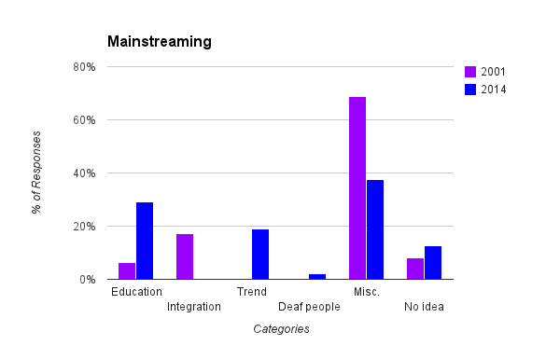

31.3% of those interviewed associate the English word ‘mainstreaming’ with education and Deaf students (arrived at by collapsing the first and fourth response categories). A large percentage of the responses referred to “following a trend”. Conversely, 50% of respondents either did not understand the term or did not associate the term with any semantic sense that bears a resemblance to what interpreters think they are communicating when they use the English word. Perhaps most revealing is the following list of some of the miscellaneous responses:

*Table 1.*

|  |  |
| --- | --- |
| Technology  Media  Radio  Pop music | Drug use  Headliner  Popular culture |

The higher percentage of responses corresponding to education in the current study could be due to the *No Child Left Behind Act* (No Child Left Behind Act of 2001), which was instituted in 2001, two years after the first survey was completed. Since that time, common knowledge about education has grown and people have become more aware of the term ‘mainstreaming’ in the educational setting.

**Item #2: “cochlear implant”**

Besides simply meaning an implanted hearing device, the lexical item ‘cochlear implant’ often symbolizes “an oppressive effort to eradicate the cultures of Deaf people” or “the destruction of personal identity (particularly of d/Deaf children)” (Cokely, 2001). Analyzing the responses collected in the survey gives an indication of what semantic senses are conveyed to the English-speaking community.

The collection of responses were divided into five categories: those having to with surgery, those having to do with acoustic awareness or an implantation of a device, those specifically mentioning d/Deaf people, miscellaneous responses, and responses of the type “I don’t know”, etc. The following graph illustrates the distribution of responses:

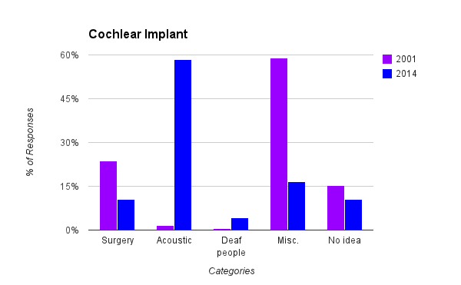

Surprisingly, only 27% of respondents did not know or did not associate the term “cochlear implant” with any semantic sense that interpreters believe they are communicating when using this lexical item. Below is a list of the miscellaneous responses that exhibit how people react to this word:

*Table 2.*

|  |  |
| --- | --- |
| Infection  Fake  New sense | Something you wear  Hearing |

    In the 2001 study, ‘surgery’ was most thought of, excluding the miscellaneous category. Now, however, 58.3% of responses were associated with something having to do with acoustics, or a device to aid hearing.  The reasoning for this could be due to the exposure of success stories posted on social media sites. When hearing stories about cochlear implants, one does not hear about the gruesome details of the surgery, but of success stories of people being “cured” of their deafness.

**Item #3: “sign language”**

The lexical item “sign language” refers to a communication system. The definition provided by Valli and Lucas (2002) states that a communication system “is a rule-governed system that users know and follow” (p. 5). Without rules, communication systems would not exist. When conducting the survey, we aimed to see how participants would consider “sign language” as a communication system. After analyzing the responses collected, we were given an indication of what semantic senses are conveyed to the English-speaking community.

The collection of responses were divided into five categories, which differ slightly from the original study: those having to do with language and communication, those having to do with gestures, those having to do with d/Deaf people, miscellaneous, and those relating to a handicap. Because none of the respondents responded by saying they do not know, a “handicap” category was added in its place due to the large number of those types of responses. The following graph illustrates the distribution of responses:

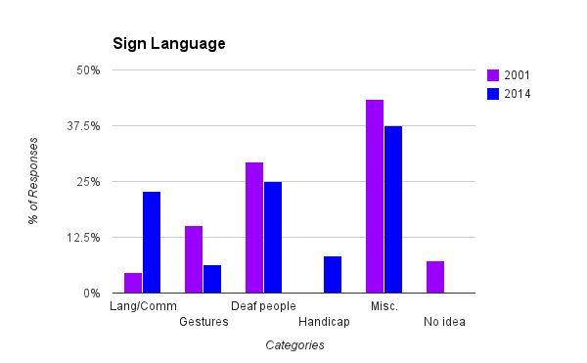

Of the 48 responses, 54.2% of respondents associated the word “sign language” to communication, whether specifically language or gestures. Of that number, 46% associated the English word with d/Deaf people.  Despite the large percentage of respondents who positively associate the word, 8.3% associate the word as a term of handicap, which is an increase from the 0% in the 2001 study. Some of the miscellaneous responses include:

*Table 3.*

|  |  |
| --- | --- |
| Really fast hands  Speech  Hands  Fingers  Strong | Something I would like to learn  Should be a mandatory class  Blind  Helpful |

In the original study, 15.1% of participants thought of sign language in terms of gestures rather than a language and mode of communication. Today, only 6.3% of respondents had answers centered on gestures, while 22.9% thought of sign language as a language. Compared to the 4.7% of people in the 2001 study who thought of sign language as a language, this is a huge increase. In the 1970s, William Stokoe and colleagues worked towards providing the linguistic analysis that helped recognize ASL as an actual language (Stokoe, 2005; 1965). It may have taken forty plus years, but slowly more and more people are recognizing sign languages as real languages instead of simply pantomime gestures.

**Item #4: “ASL”**

  ASL is the indigenous language of the American Deaf community, differing linguistically from English (Stokoe, 2005). Interpreters often use the acronym ASL in formulating their interpretations. When they use that specific acronym, however, it is not clear how many people from the English-speaking community know what is meant.

Responses were divided into five categories, which differ slightly from the original study. The original study had categories of language and communication, gestures, deaf people, miscellaneous, and no idea. Because none of the responses collected in the replicated study fit into the category of deaf people, this category was replaced with American Sign Language. The categories became: American Sign Language, those related to language and communication (not mentioning American Sign Language specifically), those related to gestures, miscellaneous responses, and the type “I don’t know” etc. The following graph illustrates the distribution of responses.

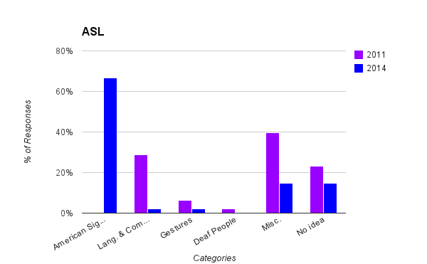

  In the original study, only 37.4% of those interviewed associated the English acronym with a form of “gesturally produced and visually received communication” (Cokely, 2001). In the replicated study, however, 66.6% of respondents explicitly said ‘American Sign Language’. An additional 4.2% had answers related to communication and/or gestures. While there was a large percentage of people who associated ‘ASL’ with the same semantic sense as interpreters, 29.2% had no idea what ‘ASL’ stood for or had different associations, which are shown in the following list of miscellaneous responses:

*Table 4.*

|  |  |
| --- | --- |
| Everyone’s favorite college elective  American standard of living  A speech language | Age, Sex, Location  Internet |

ASL is becoming increasingly more popular and well known. As ASL is becoming introduced in the media and current events, more people are becoming familiar with the term and what it means.

**Item #5: “gallaudet”**

The lexical item “gallaudet” typically refers to the Washington, D.C. university where the majority of their faculty, staff, and students communicate through the use of ASL.  Interpreters routinely use this English lexical item in formulating their interpretation. Analyzing the responses collected in the survey gives an indication of what semantic senses are conveyed to the English-speaking community.

The collection of responses were divided into five categories: those that were completely accurate, those that were presumably close, those mentioning d/Deaf people, miscellaneous responses, and responses of the type “I don’t know”, etc. The following graph illustrates the distribution of responses:

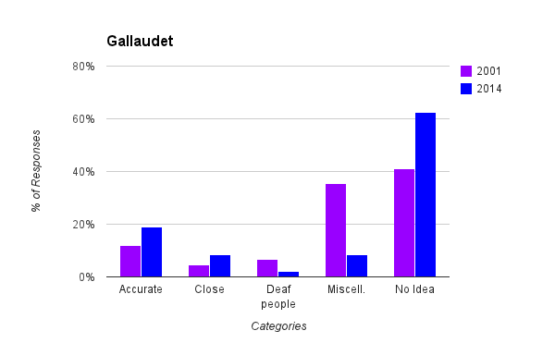

29.2% of those interviewed associated the English word ‘gallaudet’ with post-secondary education for d/Deaf students (arrived at by collapsing the first and second response categories).  62.5%, of the responses were categorized as no idea, showing that people do not readily or easily associate the lexical item with a semantic sense that bears a resemblance to what interpreters are trying to convey. Perhaps most revealing due to the fact that these responses are completely unrelated to the university, is the following list of some of the miscellaneous responses:

*Table 5.*

|  |
| --- |
| Scientist  Ear Device  Romeo  Glove |

No significant changes were found when looking at the 2001 and 2014 studies besides the fact that the miscellaneous responses had decreased, while the “no idea” responses increased.  However, the responses that were accurate or reasonably close had increased by 10.3%. Although this percent is not substantial, it is important to be aware that the knowledge about Gallaudet University has increased.

**Item #6: “hearing”**

The lexical item “hearing” is often referred to as being part of the majority or communicating in a vocal and auditory sense.  Depending on the location of this sign the semantic sense can also mean an oppressive community along with other meanings to represent that “they are not one of us” (Cokely, 2001). While interpreters use the word “hearing” during their interpretation, views of the English-speaking community may differ.

The collection of the responses were divided into five categories: audiologic capabilities, mentioning a sense or sensation, those whose identity to belong to a socio-cultural group, miscellaneous responses, and responses of the type of “I don’t know”, etc.  The following graph illustrates the distribution of responses:

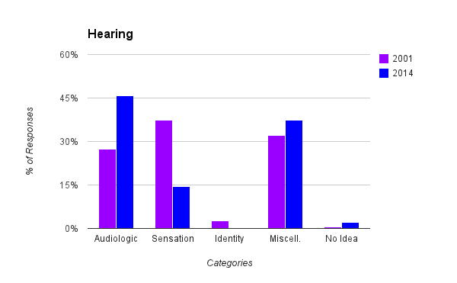

Of the 48 responses that were given, 60.4% of the respondents identified ‘hearing’ as an audiologic capability or relative to a sensation (collapsing the first two categories).  None of the respondents had associated the English lexical item with the semantic sense of identity, while 2.1% of the participants indicated that they did not link any semantic sense to the lexical item that interpreters may use throughout their interpretation. Table 6, below, shows a list of some of the miscellaneous responses:

*Table 6.*

|  |  |
| --- | --- |
| Ears, sound, music  Big Meeting  Blessed to have it  Gift taken for granted | Don’t think about it  Loss  Ears  Court |

When comparing the two studies, 18.4% more responses were associated with audiologic capabilities in the current study, and the responses relating to sensation in the original study had decreased by 22.8%.  Commonly in the English-speaking community, individuals do not identify themselves as hearing, but will identify themselves based on gender, race, ethnicity, etc.  Furthermore, they also tend to think of hearing as a capability and something they are able to do.

**Item #7: “hard of hearing”**

Often, interpreters will use the lexical item “hard of hearing” in their interpretations to refer to someone who may be able to pass as a hearing person or someone who may be ambivalent about their identity (Cokely, 2001).  When an interpreter uses this English word in their interpretation, the English-speaking community and the interpreter’s semantic sense may differ from one another.

The responses were divided into five categories: audiologic capabilities, those that mentioned a sensation or relating to sense, an identity or those who belong to a socio-cultural group, miscellaneous responses, and responses of the type of  “I don’t know” etc. The following graph illustrates the variety of responses:

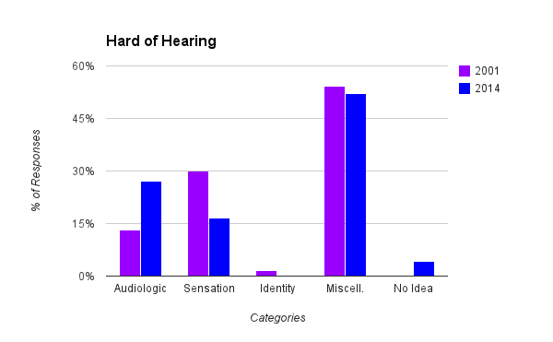

More participants in the current associated “hard of hearing” with audiologic capabilities than in the original study.  However, there were no responses that identified “hard of hearing” with a socio-cultural group.  Only 4.2% of the responses indicated that they did not associate the lexical item with a semantic sense that interpreters may assume they are communicating.  A number of the respondents associated ‘hard of hearing’ with miscellaneous semantic senses such as:

*Table 7.*

|  |  |
| --- | --- |
| People repeating themselves  Need to speak louder/clearer  Grandparents  Deaf  Elderly | Tough life  Too many loud noises  Louder television, stereo, etc.  Challenged  Hearing Aids |

**Item #8: “deaf”**

The lexical item “deaf” is often referred to as describing someone who uses a language that is gesturally produced and visually received, or someone who is part of a minority, both culturally and linguistically (Cokely, 2001).  The set of data was arranged into five categories, although one of the categories differs from the original study due to the fact that none of the respondents had associated the lexical item ‘deaf’ with a socio-cultural identity.

In the replicated study the five categories were: audiologic capabilities, those to mention a sensation or relating to the sense, those who responded with sign language, miscellaneous responses, and whose answer were similar to “no idea” or “don’t know”.

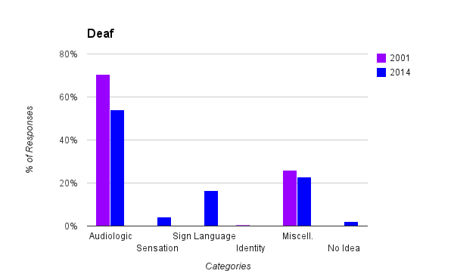

In the original study, 70.5% or the respondents associated ‘deaf’ as audiologic capabilities, which decreased to 54.2% in the replicated study.  Due to the fact that no respondents associated “deaf” with a socio-cultural group or as an identity the category was replaced with “sign language” (16.6%). 25% of the respondents didn’t associate the lexical item with a semantic sense or had different associations, which are represented in the following table:

*Table 8.*

|  |  |
| --- | --- |
| Respect  Grab a pen or use the ABC’s  Disability | Someone who is living a different way  Rochester Institute of the deaf  Old age, birth defect |

In 2001, a mere .05% of the participants made a connection between ‘deaf’ and a sociocultural group or identity. In 2014, however, no one made this association. Due to this, the identity category was replaced with a sign language category.

**Item #9: “Deaf President Now”**

Deaf President Now was a student-led protest in March of 1988 that resulted in the appointment of the first Deaf president at Gallaudet University.  This lexical item was an addition in the current study to gain a sense of how this phrase is viewed and associated within the English-speaking community and whether or not it is associated with the famous protest.

After analyzing the data, five categories were developed: those whose responses were completely accurate, those that were reasonably close, responses that involved US politics, miscellaneous responses, and responses such as “I don’t know” or “nothing comes to mind”.

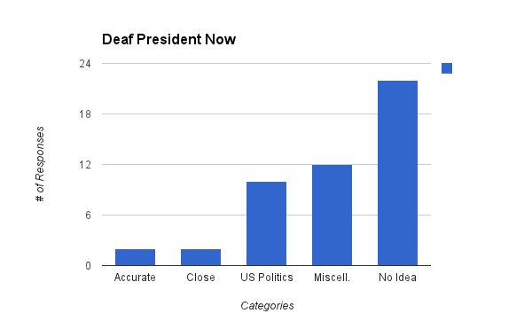

By collapsing the first two categories, a mere 8.4% of the respondents were either accurate or reasonably close when associating ‘Deaf President Now’ with its proper semantic sense.  20.8% of the responses were associated with U.S. politics, whereas a majority of the participants (45.8%) stated, “I don’t know” or “no idea”.  The remaining 25% had miscellaneous responses. Responses listed below in Table 9 show a few revealing responses of how the participants view this lexical item, such as “hard to believe” or “impossibility”:

*Table 9.*

|  |  |
| --- | --- |
| Really?  Can’t hear now  Judgment  Interpreter  Organization | Hard to believe  Impossibility  Never  Form of listening difficulty |

**Open-ended Items**

The open-ended questions were also an addition in the current study to see how members of the English-speaking community reacted to events that have taken place in the media. Participants were asked three questions which gave them an opportunity to respond openly.

**Question 1:**

*Do you think you could tell the difference between an actual interpreter and a pretend interpreter? How?*

When asked this question, participant responses fell into the following categories: could differentiate between an actual interpreter and a pretend interpreter, would not be able to tell the difference, were unsure, or had miscellaneous responses. These categories were further condensed into yes, no, maybe, and other.

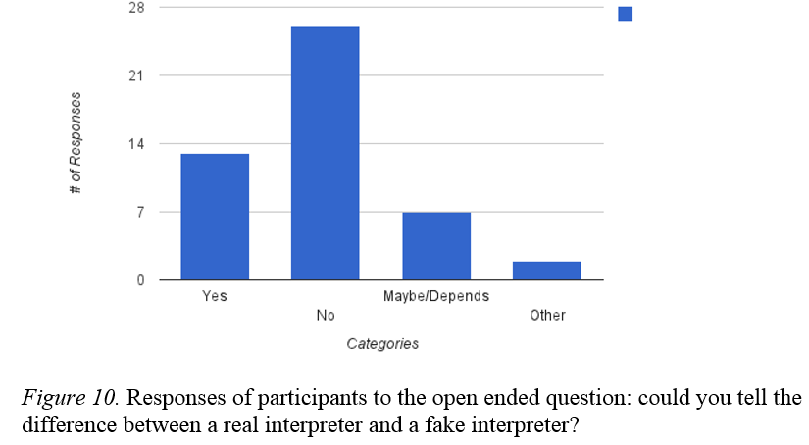

Most of the responses under the “no” category were responses that stated one must know sign language well enough in order to determine the difference between and an actual and pretend interpreter. Some respondents said they would not be able to differentiate for ASL interpreters, but would be able to spot a pretend interpreter for a spoken language (i.e. Spanish).

The “other” category consisted of responses that did not make sense and/or did not answer the question. The responses are listed below:

*Table 10.*

|  |  |
| --- | --- |
| Comfort and friendship of the interpreter and deaf friend | How intensely they sign |

**Question 2:**

*Do you think it takes longer to become a spoken language interpreter or an American Sign Language interpreter? Why?*

With this question, the expectation was that people would reply that it takes spoken language interpreters longer to become interpreters. The results from the survey, however, showed unexpected results (see below). The results were separated into four categories: becoming a spoken language interpreter takes longer, becoming a sign language interpreter takes longer, becoming a spoken and sign language interpreter takes the same amount of time, and other/do not know.

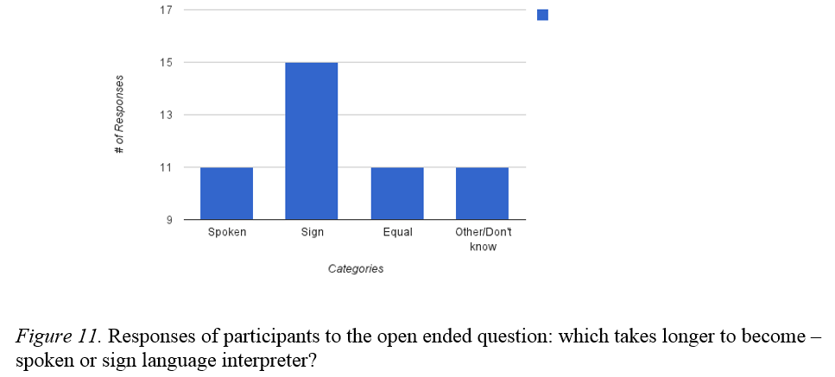

Rather than more respondents believing becoming a spoken language interpreter takes longer, the results from the survey show exactly the opposite. 31.3% of respondents thought becoming a sign language interpreter takes longer, while only 22.9% thought becoming a spoken language interpreter takes longer. Results for the spoken, equal, and other categories were equally distributed.

Among those who believed it takes longer to become a sign language interpreter, some of the reasoning was because ASL was perceived by respondents as more complicated language compared to spoken languages. Respondents’ reasonings were that a complexity of the different hand signals exists that one must learn, and that the brain must work harder to listen to what is being said and produce signs. The fact that more respondents chose sign language interpreting shows that ASL is considered by the English-speaking community as a real, complex language.

**Question 3:**

*What do you know about the interpreter for the Nelson Mandela memorial?*

The last open-ended question asks members of the English-speaking community what they know about the interpreter who interpreted the memorial service. From this question, we were curious to know exactly how much participants knew and how it influenced their choices for the other two open-ended questions. Because there is no way to quantify the results of this question, a graph is not provided.

Of the people who said they could tell the difference between actual and pretend interpreters, some of their responses include:

*Table 11.*

|  |  |
| --- | --- |
| Heard on the radio that he made up random words;  The interpreter was a fake and was not correctly interpreting the words expressed;  He was a fake and making it up;  He embarrassed himself;  He’s a fraud;  Very little if anything; | Have heard on the news he wasn’t contributing anything;  He wasn’t a licensed or certified interpreter;  He was not signing anything meaningful and in fact did not know sign;  Deaf people in the audience were understandably angry;  Some controversy |

Of the people who said they could not tell the difference between actual and pretend interpreters, their responses were relatively the same as those who could tell the difference. Due to extensive media coverage and reports, most people, regardless of if they know anything about the Deaf community, had the same thoughts on the interpreter for the Mandela memorial.

**Limitations of Study**

There are, of course, limitations of the collected data that must be stated before beginning to discuss the implications of the results. First, the sample size of the original study (n=190) was a relatively small sample. The sample size of the replicated study was even smaller (n=48). Although the replicated study is only 25% of the original study, the data represents a larger variety of demographics. Interviews were obtained from not only the Boston area, but from surrounding New England states, plus New York, Pennsylvania, and Delaware, and Tennessee.

**Implications for Interpreters**

The purpose of this study was to determine how interpreters may use these lexical items during an interpretation and the correlation between the English words and their semantic senses in the English-speaking community.  The results of the study confirm that interpreters and the English-speaking community often do not associate the lexical items with the same semantic sense.  For example, a large percent of the English-speaking community views mainstreaming as something that is trending or popular at the time, whereas most interpreters often associate it with being in a public school.

Interpreters must remember the importance of “the day before” during their interpretations, keeping in mind what information they are privy to. In other words, what it was like for interpreters before they knew anything about the Deaf community. The results of this study show that although the English-speaking community’s view of ASL and Deaf communities are slowly changing and evolving, interpreters should be cautious of their word choices when interpreting from ASL to English. Instead of choosing to use words such as “mainstreaming”, “ASL”, or “deaf institute” (to name a few), interpreters should find different ways to convey the meaning of culturally rich signs in a way that will be understandable to the general English-speaking population in order to accurately convey the message.

**Future Research**

The current study has concentrated on English lexical items that interpreters feel convey culturally rich realities and how the English-speaking community of the Boston metropolitan area reacts to such lexical items. There are many questions this study did not focus on. Future research should address: Would the results from a larger scale study draw the same conclusions? Would similar results be found if this study were replicated in other regions of the country, besides New England? In other Deaf communities around the world? How would members of the Deaf community respond if surveyed about culturally rich realities of the English-speaking community, and how would interpreters need to reframe their interpretations? To expand these concepts further, we propose a study to be done looking at the word frequency in interpretations today and creating a survey around those meanings.

**References**

Cokely, D. (2001). Interpreting culturally rich realities. *Journal of Interpretation,* 1-44.

Gumperz, J. (1964). Linguistic and social interaction in two communities. in Blount, Benjamin.

(ed.) *Language, Culture and Society*. 14:283-299.

Hoffmeister, R. (1994). Metalinguistic skills in deaf children: Knowledge of synonyms and

antonyms in ASL. In B.D. Snider (Ed.), *Post-Milan ASL and English Literacy: Issues, Trends, and Research: Conference Proceedings* (pp.151-76).

Hymes, D.H. (1964). Directions in (ethno-)linguistic theory. *American Anthropologist*, 66(3).

Katan, D. (1999). Translating cultures. Manchester, UK: St. Jerome.

Kearns, K. (2011). *Semantics* (2nd ed.). New York: Palgrave Macmillan.

Levinson, S. (2000). Presumptive meaning. Cambridge, MA: MIT Press.

Lyons, J. (1977). *Semantics*. Cambridge: Cambridge UP.

Seleskovitch, D., & Lederer, M. (1995). *A systematic approach to teaching interpretation*. Silver

Spring, MD: Registry of Interpreters for the Deaf.

Stokoe, W., & Casterline, D. (1965). *A dictionary of American Sign Language on linguistic*

*principles* (New ed.). Silver Spring, MD: Linstok Press.

Stokoe, W. (2005). Sign Language Structure: An outline of the visual communication systems

of the American Deaf. *Journal of Deaf Studies and Deaf Education,* 3-37.

The Elementary and Secondary Education Act (The No Child Left Behind Act of 2001). (n.d.).

Retrieved from <http://www.ed.gov/esea>

Quigley, S.P. & Youngs, J. P eds. (1965). Interpreting for deaf people. Washington, DC: U.S.

Department of Health, Education, & Welfare.

Valli, C. (2011). *Linguistics of American Sign Language* (5th ed.). Washington, DC: Gallaudet

University Press.